MCS 2015 Alumni Newsletter
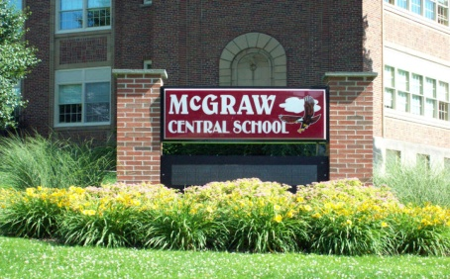

Many thanks… to Mary Jane Snyder Neff, Sue McNamera Gilliland, Roger Horak, & Gary Henry of the Class of 1965 for organizing the 2015 banquet.

Program… To honor our country we recited the Pledge of Allegiance and asked that any armed forces members rise & be thanked for their service. We remembered our classmates that have passed in a moment of silent prayer: Gary Bradshaw, Norman Bradshaw, Jerrod Clark, John DeYoung, Mary Helen Evans Sexton, William Greenleaf, William Hulslander, Linda Mallery, Loretta Parkin Beaumont, Phyllis Ryan Pettigrossi, John Rich, Larry O’Donnell, Shirley Kinney and Steve Horner. The Invocation was given by Roger Horak. The Class recognized Gene & Marilyn Bacon Barker for traveling the farthest from home to attend, Ken Welsh for living the closest to school, Dorothy Bentall Bilodeau for being the eldest alumna present (1950) and Garrick Henry for being the youngest alumnus present (1991). Dick Moore, Class Vice President, shared memories & highlights of 1965. The program was closed with the singing of our Alma Mater & a prayer for safe travels for all attendees.

Mary Sandy Guernsey, Class of 1970, was the winner of the 50/50 raffle. She graciously donated her winnings to the Association. Many thanks Mary! This raffle is the only fundraiser for our Association treasury so thank you all for supporting it.

Friday, Sept 11…Members of the Class of 1965 gathered at the Crown City Steak House to get re-acquainted. Mary Jane Snyder Neff brought pictures of many of their class activities. There were only about 13 class members in attendance but those there were particularly happy that Pete Lauria & wife, Maggie, made the trip up to be with them. Pete was Class President for their Senior year. Memories were shared & a good time was had by all!

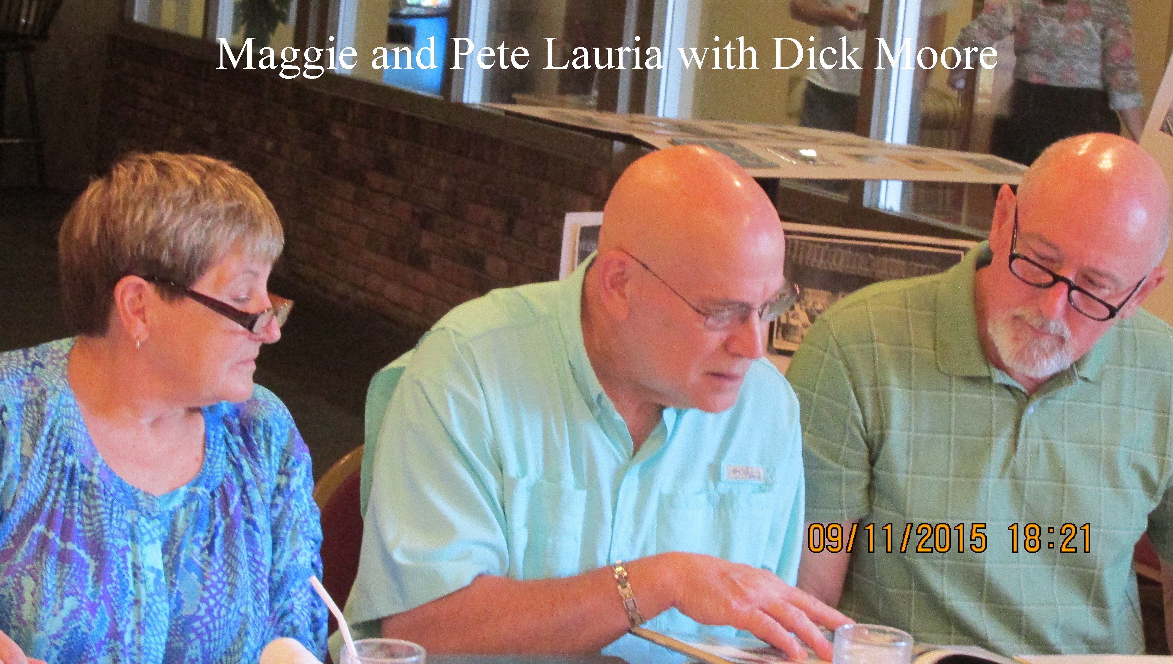

Passings…
Lt Col Vincent Willis, Class of 1942
Betty Ann Russell Davis, Class of 1950
Wilbert “Web” Kennedy, Class of 1950
Carole Jennings Owen, Class of 1951
Mahlon Pittman, Class of 1952
Joan Belknap Root, Class of 1953
Norman “Stub” Alcott, Class of 1961
Jean Morgan Fish, Class of 1962
Raymond Paul Beyer, Class of 1963
Carole Fuller Treacy, Class of 1964
Steve Horner, Class of 1965
John Rich, Class of 1965
Mary Helen Evans Sexton, Class of 1965
Joe Harris, Class of 1968
Alan Stebbins, Class of 1970
Arlene Stevens Hill, Class of 1970
Brian McLean, Class of 1975
Cathy Gilbert Crumb, Class of 1975
Brandon Mack, Class of 2007
Terry Keeney Bugh, Faculty (English)

Treasurer’s Report (10/2014 –10/2015)

Sept 2014 Balance Forward $ 1,749.90

Expenditures
2015 Name tags $ 198.26
2014 Newsletter copying & mailing
(208) $ 318.64
2015 Postcards $ 244.98
2015 Banquet $ 4,427.36

Receipts
2015 Banquet $ 4,172.00
Annual interest $ .87
2015 Raffle $ 350.00
2015 Donations $ 75.00

Sept 2015 Balance $ 1,158.53

The 2014 newsletter was emailed to 450 & digitally posted to AlumniClass.com & Facebook for the 700+ McGraw High School group members. 215 hard copies were hand delivered &/or mailed to alumni from the classes of 1935-1966. 389 banquet notification postcards were mailed in June 2015.

MCS Website
Check out the MCS website http://www.mcgrawschools.org Lots of interesting news in the monthly newsletter, The Eagle Tribune, as well as the District & school annual calendars. It’s a great place to keep up with school news.

McGraw Historical Society reaches out to McGraw friends... Last winter the McGraw Historical Society posted a number of photographs to the Alumni Group on Facebook. At the banquet, many of you mentioned that you enjoyed them a great deal. It is my intent to do this again & we thank the Alumni Committee for the use of their site. After recent discussion with the Committee, the Historical Society has received permission to set up a display at the 2016 banquet. This display would consist of memorabilia pertaining to the Village and school. We may also have copies of books we have printed for sale; "Faces of McGraw", "St. Joseph's Church", "Post Cards of McGraw", "Stained Glass Windows of McGraw" & "Facts, Folklore & Fiction of McGraw". It is our hope that this will add to the banquet event & act as a fund raiser for the Society. Sincerely, Carl Kimberly, President, McGraw Historical Society

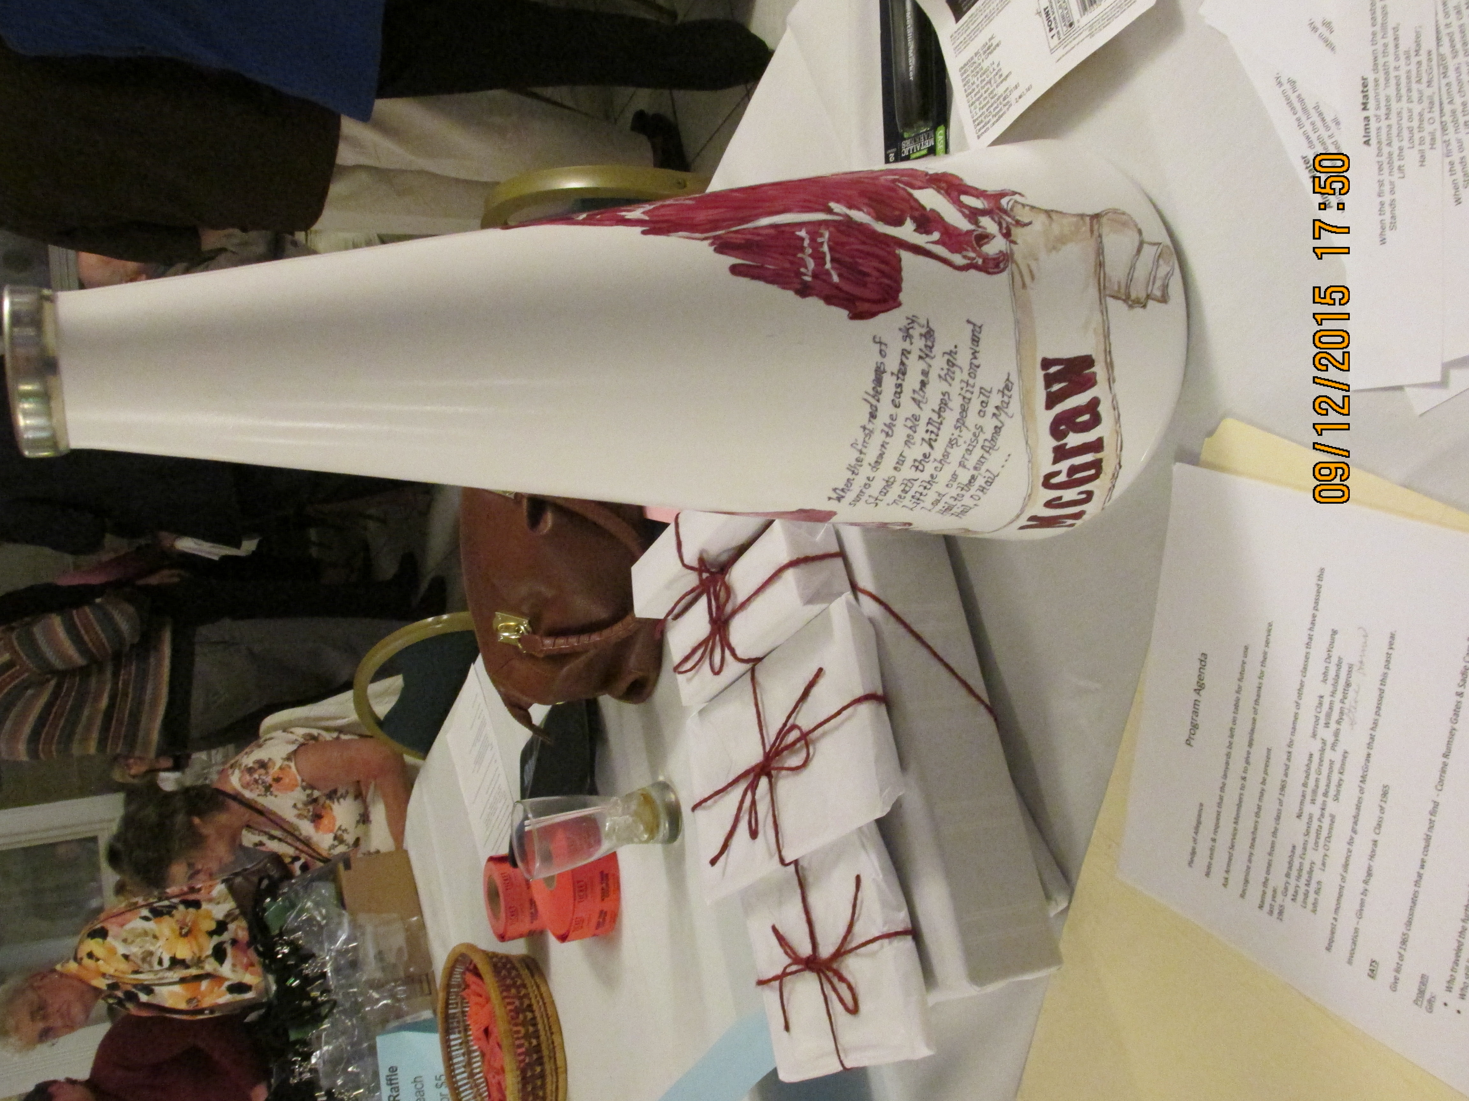
Attention Class of 1966… 50 years can you believe it? It's our class's privilege to host the fall 2016 McGraw Annual Alumni Association banquet. Great fun, great food and great event to get together. We have a 1966 class committee put together for planning & will be reaching out to our classmates for contact information & updates. Contact Don Card (dcard85@gmail.com or 607 756 1842 ) for additional information.

The Association received a lovely note from Mary Fraser Heffernan, Class of 1946, thanking us for sending her the newsletter. She “appreciates reading about the graduates, McGraw happenings & pictures too”. Mailing the newsletter to our older alumni means a lot to them. Many are unable to attend but still want to feel a part of our association. Thanks to all of you for supporting the 50/50 raffle at the Banquet each year & for thinking of us with donations throughout the year…your support enables us to continue to do this.

Banquet attendance:
Class |  |  | Last | First |  |  |  | Maiden
1950 |  |  | Bilodeau | Dorothy |  |  |  | Bentall
1951 |  |  | Potter | Russell
1952 |  |  | Abdallah | Bert
1953 |  |  | Beattie | James
1953 |  | Kimberly |  | Carl
1953 |  | Brown |  | James
1954 |  | Howard |  | Joan |  |  | McNamara
1954 |  | McGuinness |  | James Sr.
1954 |  | Jacobi |  | Robert
1954 |  | Elwood |  | Rollan
1954 |  | Snyder |  | Philip
1954 |  | Ackley |  | George Jr
1955 |  | Wainwright |  | Nancy |  |  | Smith
1955 |  | Strack |  | Ed
1955 |  | Welsh |  | Ken
1956 |  | Snyder |  | Vivian |  |  | Russell
1956 |  | Mitchell |  | Sylvia |  |  | Ryan
1956 |  | Gilbert |  | Malcolm
1956 |  | Phillips |  | Robert
1956 |  | Kempisty |  | Beverly |  |  | Nauseef
1956 |  | Allis |  | Janice |  |  | VanEpps
1956 |  | Card |  | Carole |  |  | Hoose
1957 |  | Niles |  | David
1957 |  | Mitchell |  | Jack
1958 |  | Loope |  | John
1958 |  | Allis |  | Richard
1958 |  | Card |  | Robert
1959 |  | Abdallah |  | Diane |  |  | Allis
1959 |  | Albro |  | Barbara |  |  | Gates
1959 |  | Carr |  | Donel
1959 |  | Potter |  | Connie |  |  | Garner
1959 |  | Ackley |  | Barbara |  |  | Alcott
1960 |  | Moeller |  | Gerri |  |  | Walburn
1960 |  | Niles |  | Ann |  |  | Phelps
1960 |  | Wright |  | C. William
1960 |  | Green |  | Judy |  |  | Freer
1960 |  | Snow |  | Sarah |  |  | VanEpps
1960 |  | Dodge |  | Raymond
1960 |  | Barker |  | Gene
1960 |  | Osborne |  | Richard
1961 |  | Crisfield |  | David
1962 |  | Aldrich |  | Laura |  |  | Heath
1962 |  | Taylor |  | Wilma |  |  | Phelps
1962 |  | VanEpps |  | David
1962 |  | Barker |  | Marilyn |  |  | Bacon
1962 |  | Hamilton |  | Sharon |  |  | Schellinger
1963 |  | Towers |  | Lilla |  |  | Elwood
1963 |  | Reardon |  | Roberta |  |  | Mallery
1963 |  | McNeill |  | Susan |  |  | Benedict
1963 |  | Stewart |  | Joan |  |  | Osborne
1964 |  | Osborne |  | Ray
1965 |  | Horak |  | Roger
1965 |  | Talbot |  | Dale
 | 1965 | Weisbrod |  | Barbara |  |  | Atkins
 | 1965 |  | Neff |  | Mary Jane |  |  | Snyder
 | 1965 |  | Wiggans |  | Elizabeth |  |  | Bonsteel
 | 1965 |  | Guernsey |  | Bill
 | 1965 |  | Fox |  | Shirley |  |  | Widger
 | 1965 |  | Benjamin |  | Roberta |  |  | Ames
 | 1965 |  | Moore |  |  | Dick
 | 1965 |  | Gilliland |  |  | Sue |  | McNamara
 | 1965 |  | Henry |  |  | Gary
 | 1965 |  | Denkenberger |  |  | Vivian |  | Tobias
 | 1965 |  | Schmidt |  |  | Gary
 | 1966 |  | Friedah |  |  | Scott
 | 1966 |  | Friedah |  |  | April |  | Partridge
 | 1966 |  | Ames |  |  | Thomas
 | 1966 |  | Stark |  |  | Candy |  | Reynolds
 | 1966 |  | Pease |  |  | Jack
 | 1966 |  | Card |  |  | Donald
 | 1966 |  | Schaefer |  |  | Gerald
 | 1968 |  | Hartley |  |  | Donald
 | 1968 |  | Ames |  |  | Richard
 | 1969 |  | Mallery |  |  | Lynn
 | 1969 |  | Smithers |  |  | June |  | Widger
 | 1969 |  | Walker |  |  | Elaine |  | Marvin
 | 1969 |  | Gross |  |  | Deborah |  | Stauber
 | 1970 |  | Warfield |  |  | Rick
 | 1970 |  | Hartley |  |  | Arnold
 | 1970 |  | Guernsey |  |  | Mary |  | Sandy
 | 1970 |  | Murray |  |  | Gloria |  | Puderbaugh
 | 1970 |  | VanEtten |  |  | Melinda |  | Russell
 | 1971 |  | Schaefer |  |  | Ron
 | 1971 |  | Banse |  |  | Linda |  | Hartley
 | 1971 |  | Gebczyk |  |  | Debby |  | Bonsteel
 | 1971 |  | Parker |  |  | Karl
 | 1972 |  | Bilodeau |  |  | Rene'e
 | 1972 |  | Beard |  |  | Carol |  | Eaton
 | 1972 |  | Hartley |  |  | Ronald
 | 1972 |  | Rutan |  |  | John
 | 1972 |  | Cobb |  |  | Jay
 | 1974 |  | Paddock |  |  | Catherine |  | Kullman
 | 1974 |  | Schaefer |  |  | Lenore
 | 1974 |  | Stiles |  |  | Bill
 | 1975 |  | Law |  |  | Lori |  | Cobb
 | 1977 |  | McGuinness |  |  | James Jr.
 | 1980 |  | McGuinness |  |  | David
 | 1984 |  | McGuinness |  |  | Robert
 | 1985 |  | Brown |  |  | Kristine
 | 1985 |  | Comfort |  |  | Laurie |  | Barnes
 | 1988 |  | Neff |  |  | Connie |  | Barnes
 | 1989 |  | Neff |  |  | Tim
 | 1991 |  | Henry |  |  | Garrick
 | Faculty |  | Dippo |  | Walt

Please – help us save on postage. If you haven’t already, send an email with your name (include maiden) & year of graduation to bgklock@twcny.rr.com or, send me a request to join our group on Facebook. Thanks.

Mark your calendar… The next Alumni Banquet is
September 10, 2016

